
NAME: TAHA MOIZ ELECTRICWALA
ROLLNO: 26ITB002
COURSE CODE: 1CS501CC26
PRACTICAL NUMBER: 2

AIM: (A) Scan two numbers and display result of different arithmetic operations
(+, -, *, / and %)
METHODOLOGY:
#include <stdio.h>

int main(){

int a, b;
printf("Enter first number: ");
scanf("%d", &a);

printf("Enter second number: ");
scanf("%d", &b);

printf("The sum of given numbers is: %d\n", a+b);
printf("The difference of given numbers is: %d\n", a-b);
printf("The product of given numbers is: %d\n", a*b);
printf("The division of given numbers is: %d\n", a/b);

return 0;
}
INPUT/OUTPUT:
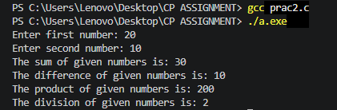
AIM: (B) A company has the following scheme for payment to their staff.
●
Net salary = Gross salary – Deduction
●
Gross salary = Basic + DA + HRA + Medical
●
Deduction = Insurance + PF
●
DA (Dearness allowance) = 50% of Basic
●
HRA (House rent allowance) = 10% of Basic
●
Medical = 4% of Basic
●
PF (Provident Fund) = 5% of Gross
●
Insurance = 7% of Gross
Calculate the net payment to any employee.
METHODOLOGY:
#include <stdio.h>

int main(){
float netSalary, grossSalary, basic, da, hra, medical;
float insurance, pf, deduction;

printf("Enter the basic pay of employee: \n");
scanf("%f", &basic);

da = 0.5*basic;
hra = 0.1*basic;
medical = 0.04*basic;
grossSalary = basic + da + hra + medical;

insurance = 0.07*grossSalary;
pf = 0.05*grossSalary;
deduction = insurance + pf;

netSalary = grossSalary - deduction;

printf("The net payment to the employee is: %f", netSalary);

return 0;
}

INPUT/OUTPUT:
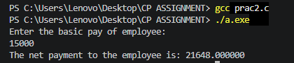
AIM: (C) To swap the value of two numbers (i) using and (ii) without using a
temporary variable.
METHODOLOGY (1):
#include <stdio.h>

int main(){
int a = 10, b = 15, temp;
printf("The initial value a and b are: %d and %d respectively\n",a ,b);

temp = a;
a = b;
b = temp;

printf("The final value a and b are: %d and %d respectively\n",a ,b);

return 0;
}

METHODOLOGY (2):
#include <stdio.h>

int main(){
int a = 10, b = 15, temp;
printf("The initial value a and b are: %d and %d respectively\n",a ,b);

a = a-b;
b = a+b;
a = b-a;
printf("The final value a and b are: %d and %d respectively\n",a ,b);

return 0;
}

INPUT/OUTPUT:
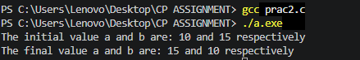
AIM: (D) To find the greatest of two using
METHODOLOGY:
#include <stdio.h>

int main(){
int a=10, b=20, greater;

greater = (a>b)? a: b;

printf("The greatest number amongst two is: %d", greater);
return 0;
}

INPUT/OUTPUT:


